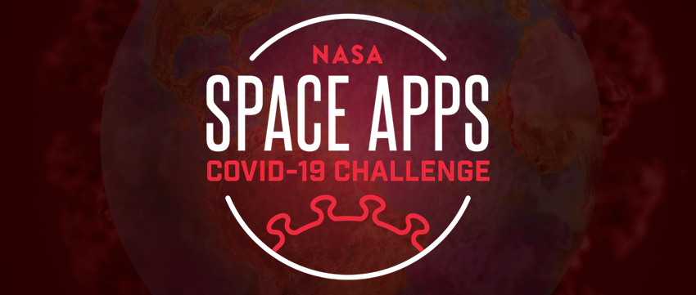

Expert volunteer sign up
Calling all European subject-matter experts to volunteer for NASA - in collaboration with ESA and JAXA - Space Apps COVID-19 Challenge!

DEADLINE TO SIGN UP IS MAY 15, 2020.

* Required
Email address * | email address
First Name * | first name
Last name * | last name
Country * | country
Affiliation * | company/institution
Your subject-matter expertise (The Space Apps team will match you with appropriate challenges, if possible.) * | specific thematic expertise
Which of the following themes could you support as a subject-matter expert? *  Check all that apply. | ☐ Impacts of COVID-19 on the Earth as a system  ☐ Human population migrations and nighttime lights imagery  ☐ Environmental factors of COVID-19 spread  ☐ Impacts of reduced human traffic in protected environments  ☐ Creative responses to social isolation  ☐ Impacts of COVID-19 on the United Nations Sustainable Development Goals (SDGs)  ☐ Impacts on food supply caused by COVID-19  ☐ Indoor air purification and monitoring systems  ☐ Human factors and predicting COVID-19 spread  ☐ Adaptations to social isolation  ☐ Integrated Earth observations and socioeconomic COVID-19 impact assessment
Are you available to engage with participants in the online chat rooms on May 30-31 - answering questions about the challenges and data? *  Mark only one choice. | ☐ Yes  ☐ No  ☐ Other: please specify
Are you available to judge the submissions online (June through mid-July, exact dates to be determined)? (The Space Apps team will provide criteria and training for the judging platform.) *  Mark only one choice. | ☐ Yes  ☐ No  ☐ Other: please specify

Your consent is required
By submitting your personal information you agree to ESA framework on Personal Data Protection and to the processing of your personal data by, or on behalf of, the Agency, as mentioned in the ESA Privacy Notice and Consent form as follows:
☐I accept
☐I disagree

How and when can you withdraw your consent?
You will be able to withdraw your consent depending on the modality used to collect your personal data by sending an email to eo4society@esa.int and DPO@ESA.int.

